# **PRAKTIKUM BASIS DATA LANJUT**

**LAPORAN PRAKTIKUM**

**TUGAS 1 – BASIS DATA LANJUT**



**NAMA : PRINAFSIKA**

**NPM : 21081010278**

**PROGRAM STUDI TEKNIK INFORMATIKA**

**FAKULTAS ILMU KOMPUTER**

**UNIVERSITAS PEMBANGUNAN NASIONAL “VETERAN” JAWA TIMUR**

**2022**

**\*Data CDM**

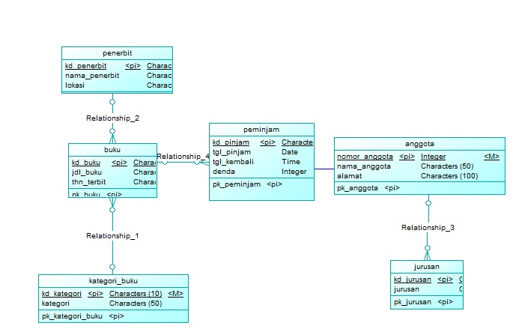

1. Syntax **DDL**
   1. CREATE
   2. ALTER
   3. RENAME
   4. DROP
   5. TRUNCATE
2. Syntax **DML**
   1. SELECT
   2. INSERT
   3. UPDATE
   4. DELETE
3. CREATE

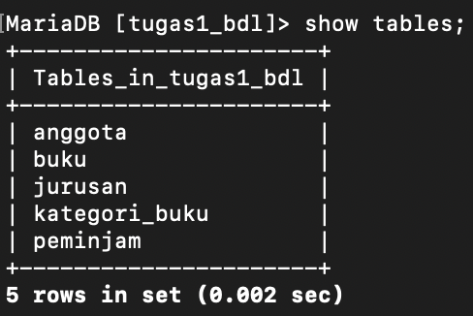

***BEFORE***

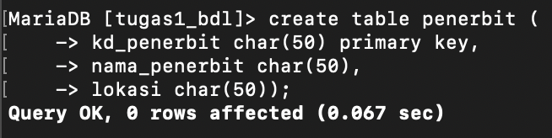

***SYNTAX CREATE***

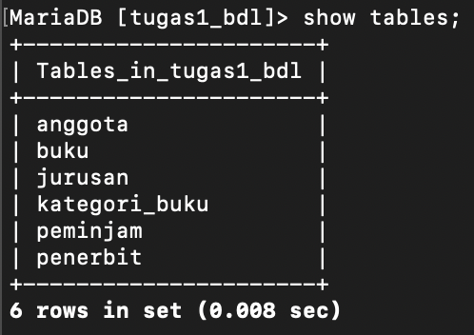

***AFTER***

1. ALTER

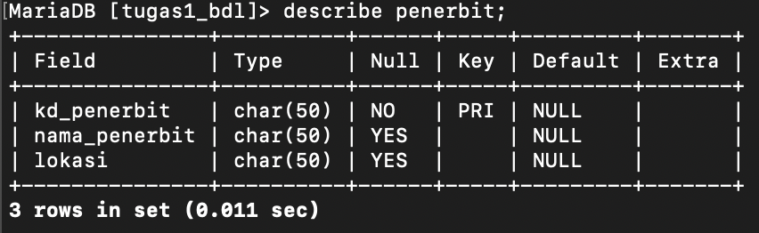

***BEFORE***



***SYNTAX ALTER***

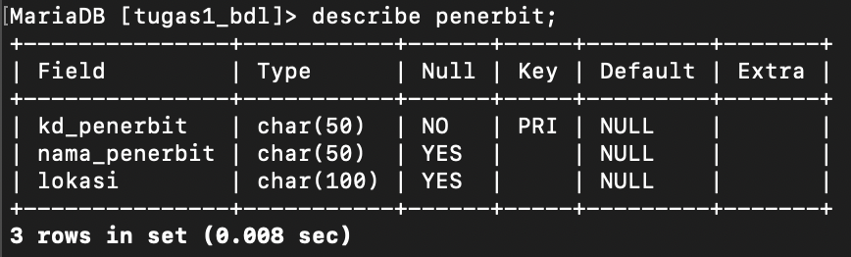

***AFTER***

1. RENAME

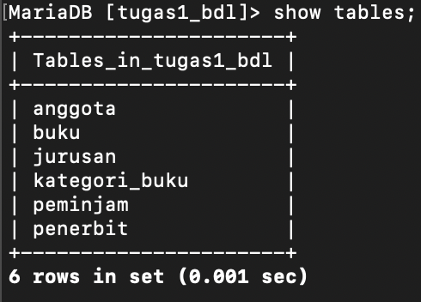

***BEFORE***



***SYNTAX RENAME***

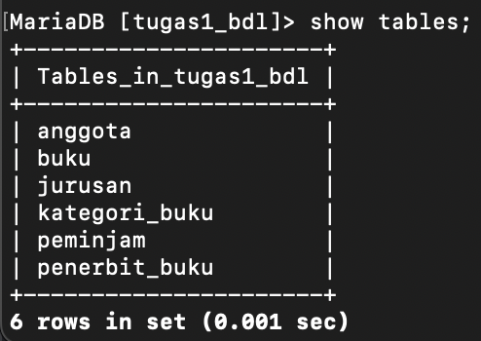

***AFTER***

1. DROP



***BEFORE***

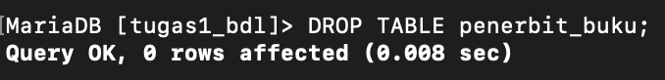

***SYNTAX DROP***

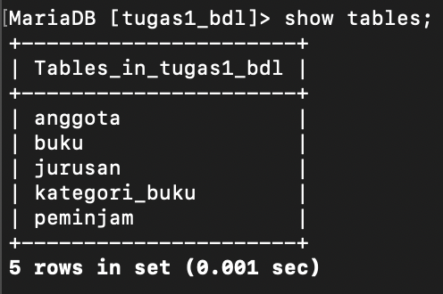

***AFTER***

1. TRUNCATE

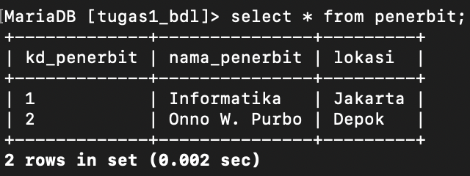

***BEFORE***

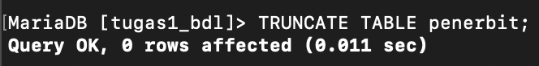

***SYNTAX TRUNCATE***

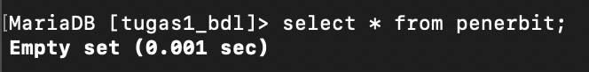

***AFTER***

1. SELECT

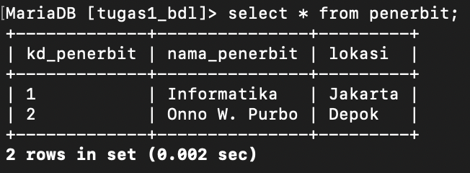

***SYNTAX SELECT***

1. INSERT

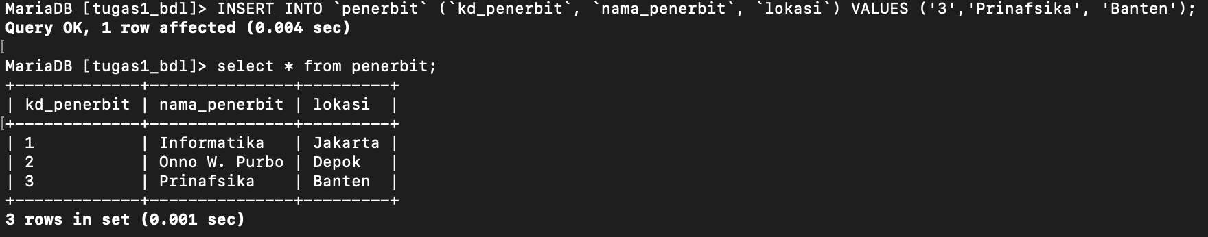

***SYNTAX INSERT***

1. UPDATE

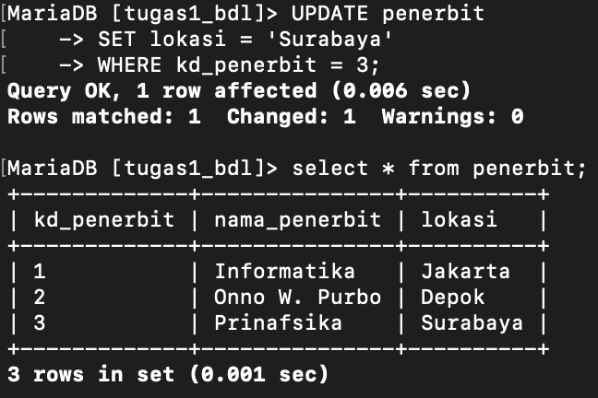

***SYNTAX UPDATE***

1. DELETE

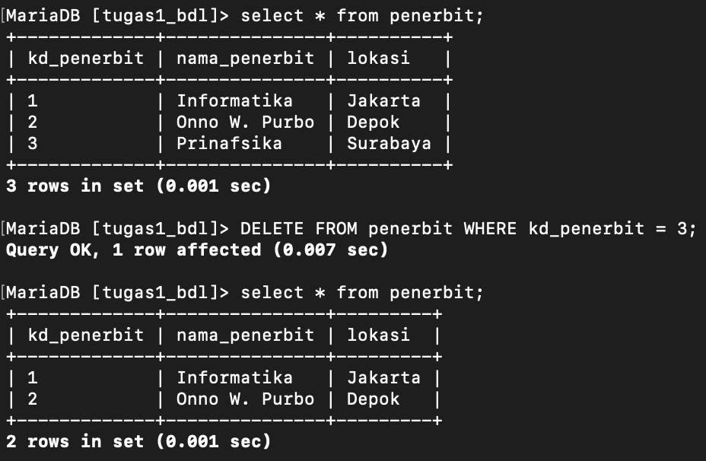

***SYNTAX DELETE***